Name: Shaizan Ulla Shariff
SRN: PES1UG24CS690
Title: Peer to Peer carpooling and expense splitter

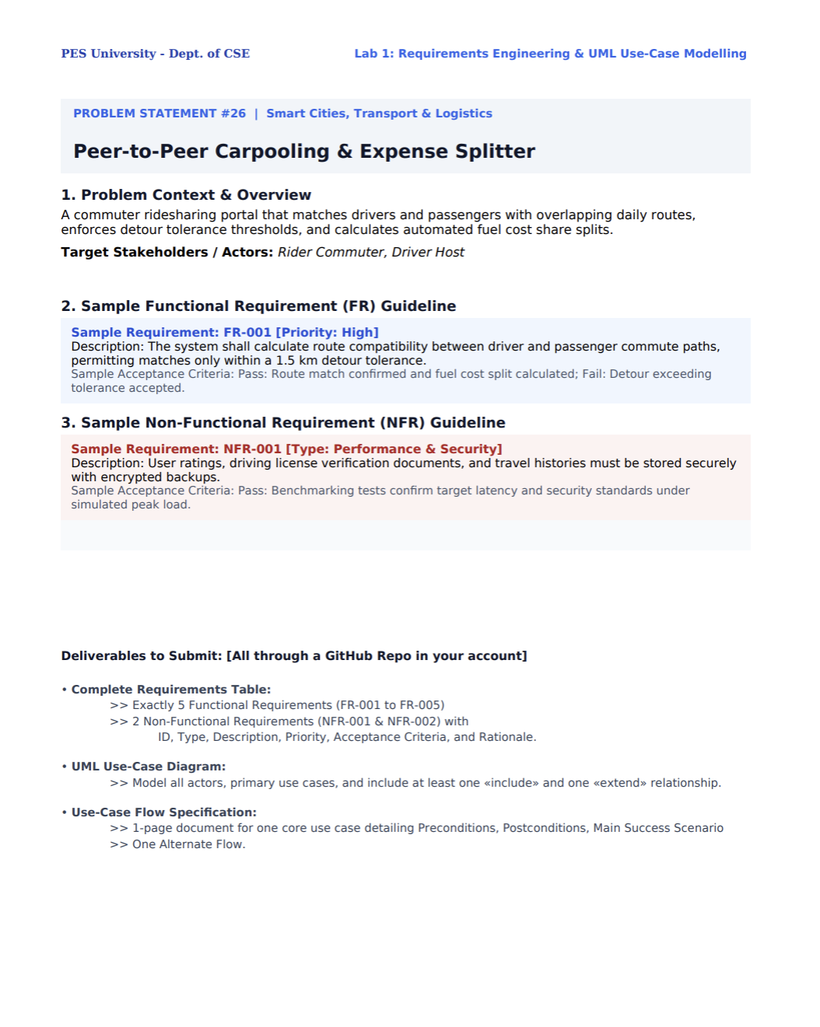

Actors:
Rider commuter,
Driver host
Payment gat4way

Main use cases:
- Calculates best route
- Finds nearest rider
- Select travel mode
- Match rider and driver
- Make payment
- Split expense of the travel

Match Rider and Driver <<include>> Find Nearest Rider
Select Travel Mode <<extend>> Match Rider and Driver

Use-Case Flow Specification
Use Case: Match Rider and Driver

Preconditions:
1.Rider and driver are registered.
2.Both have provided valid pickup and destination locations.
3.Driver has an available seat, (if two wheeler then aan extra helmet)

Postconditions:
1.A rider-driver match is confirmed.
2.Route and estimated travel details are displayed.

Main Success Scenario
1.Rider Commuter enters their pickup location and destination.
2.System calculates the best route for both users.
3.System finds the nearest suitable rider based on location and route compatibility.
4.System checks the driver's allowed detour tolerance.
5.System displays compatible travel modes such as 2-wheeler, cab, or AC cab.
6.Users select their preferred travel mode.
7.Drver gets the good fair trip matches and he can decide whether to take or not
8.System confirms the rider-driver match.
9.System calculates the estimated travel expense share.
10.The system displays the final match and expense details.

Alternate Flow – Route Not Compatible
If the rider's route exceeds the driver's allowed detour tolerance:
4a.1.The system rejects the match.
4a.2.The system searches for another suitable rider.
4a.3.If no suitable rider is found, the system informs the driver that no compatible match is available.

